THEORY QUESTIONS
PART A
[30 marks]
Answer Question 1 [Compulsory] and any other question.
1.
Mansah and her classmates are going on an excursion to Akosombo Textiles Limited. She has asked you to teach her how to prepare rock buns to be served with fruit drink as snack for the class.
(a)

(i)

Describe how to prepare the rock buns.
[5 marks]
(ii)

State two advantages of measuring the ingredients to be used for the rock buns.
[4 marks]
(b)

State one function each of the following ingredients to be used for the preparation of the rock buns:
(i)

eggs:

(ii)

flour:

(iii)

sugar:

[6 marks]

2.
(a)

Describe one of the techniques used to shape biscuit during its preparation.
[2 marks]
(b)

Mrs. Boadu prepared soup with fish powder for her toddler.
State one specific function of the major nutrient in the soup.
[2 marks]
(c)

In the sewing workshop, equipment and tools must be well arranged to prevent the occurence of accidents. Describe any one of the accidents likely to occur in the workshop.
[3 marks]
d)

State two guidelines to follow during tree planting exercise
[4 marks]
e)

State and explain two proceses in managing a business
[4 marks]

3.
(a)

State two factors to consider when selecting sewing materials
[4 marks]
(b)

Ekua made a petticoat and finished the hem using lace trimming. She is excited seeing the finished article.
State two benefits of her choice of finishing.
[4 marks]
(c)

Azumah wants to buy fresh meat to prepare groundnut soup for his grandmother.
State two factors he should consider when selecting the meat for the soup.
[4 marks]
(d)

The cotton fabric is the best choice for use as dish cloth and tea towels in the kitchen.
Explain one reason why the cotton fabric is the best choice for kitchen cloths.
[3 marks]

PART B
[30 marks]
Answer Question 4 [Compulsory] and any other one question.
4.
A student loved the idea of savings but always found it difficult to keep money without spending it. He was advised to get a money box as shown in Figure 1.
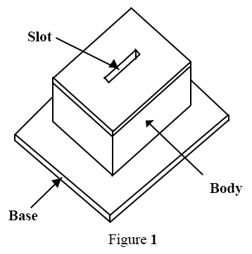
(a)

(i)

List two different types of timber suitable for producing the money box.
(ii)

Name two suitable joints to be used for assembling the body to the base.
(ii)

List two different tools for cutting the slot.
[6 marks]
(b)

Re-arrange the following procedures for making the money box in a sequential order:
I.

Mark out and cut the top hole;
II.

Assemble the workpieces by gluing;
III.

Finish off the artefact with glasspaper and apply lacquer;
IV.

Measure and mark out the workpieces;
V.

Cut the workpieces into sizes;
VI.

Prepare the joints.
[6 marks]
(c)

(i)

State one type of adhesive to be used to assemble the unit
(ii)

List two types of fasteners that can be used to strengthen the joint.
[3 marks]

5.
(a)

State one reason for carrying out each of the following workshop operations:
(i)

taking accurate measurements and marking-out workpieces;
(ii)

glasspapering a wooden artefact before applying a finish;
(iii)

fixing a hacksaw blade with the teeth pointing away from the handle.
[6 marks]
(b)

(i)

Make a pictorial sketch of a warrington hammer and label any two parts on the tool sketched.
(ii)

State one use of the warrington hammer.
[9 marks]

6.
(a)

Figure 2 shows the front view of an L-shaped wooden block. Draw the figure in single-point perspective below the eye level.
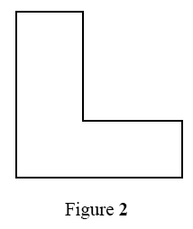
[6 marks]
(b)

A graduate aspires to be a successful business manager in the near future. List four management processes the graduate should be familiar with in order to become a good manager in future.
[4 marks]
(c)

(i)

State two primary purposes of frame structures.
(ii)

List three examples of frame structures.
[5 marks]

